**24.2 *(Query Application for the books Database)***

Anita R Goral

I struggled with this assignment so I am including all the screenshots so you can at least see what I did. First thing I did was follow the steps according to our book to set up the database. As you can see, I was able to set up the database and get it running in the command prompt. The first screenshot is of my attempts at first failing, but after playing around with it the second screenshot shows that I did in fact get the ij line running so I could start running inquires. 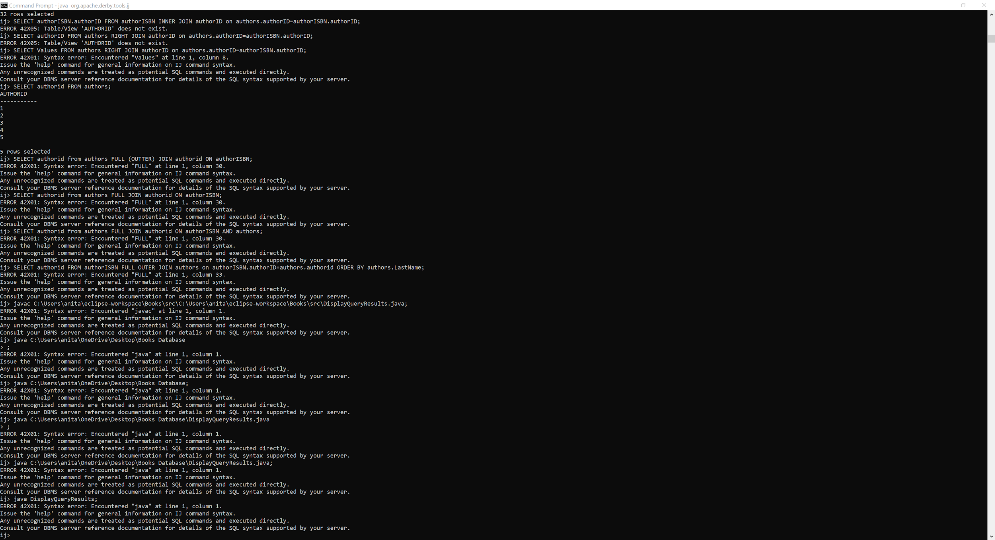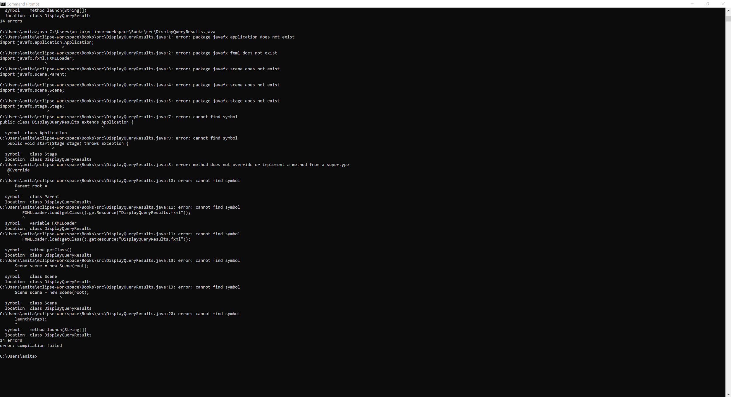

At this point I tried connecting with my program but couldn't seem to get it connected. As you can see, I can get the app running (on the first picture) but it doesn't connect to the database. When I try running the app though the command line, I get an error as well. (second picture). 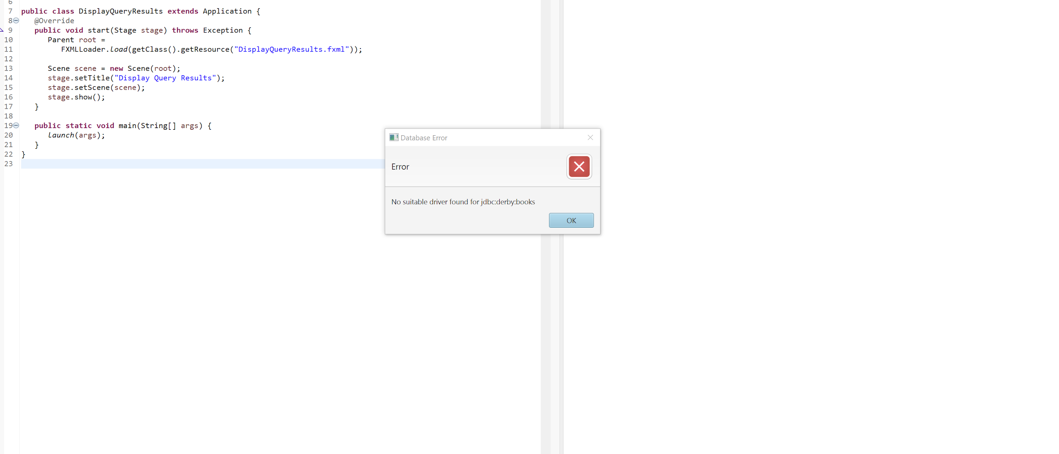

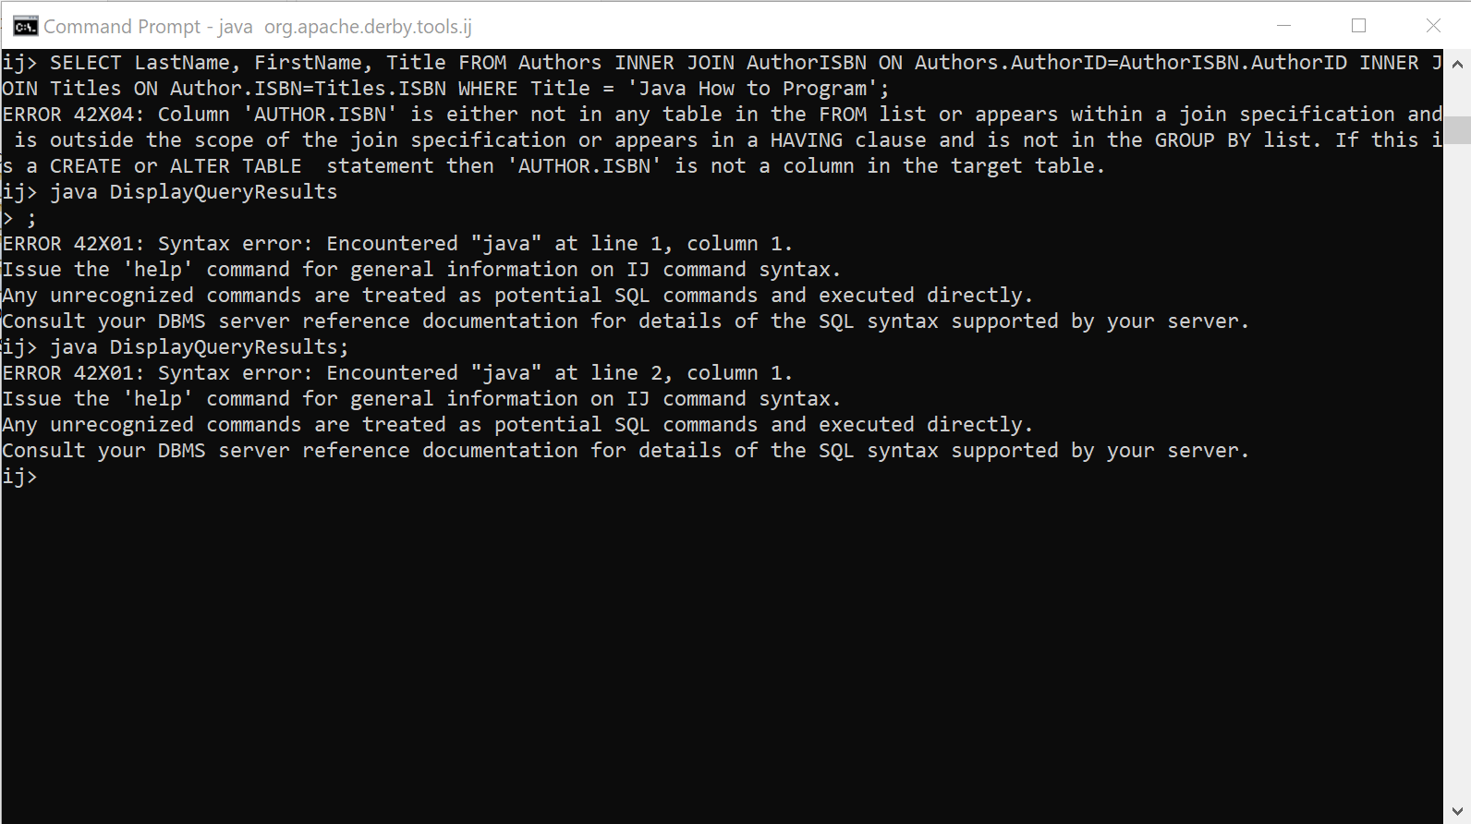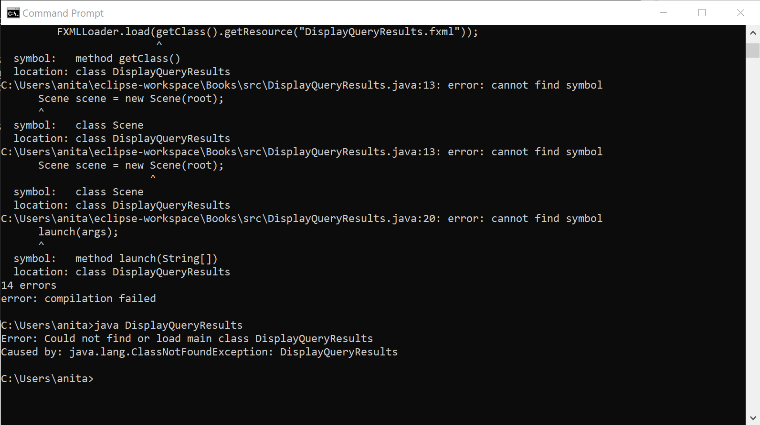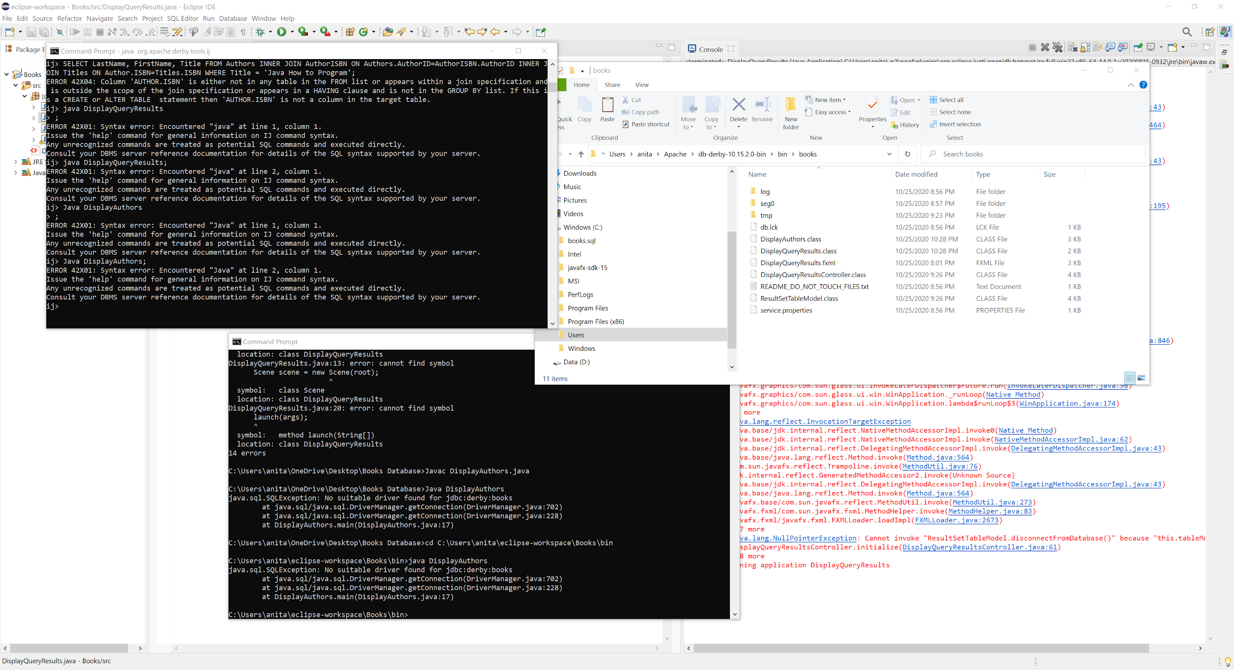

As you can see I tired alot of options. Finally I just ran some queries in the command line so I could get at least something. Here is a query to sort all the authors.

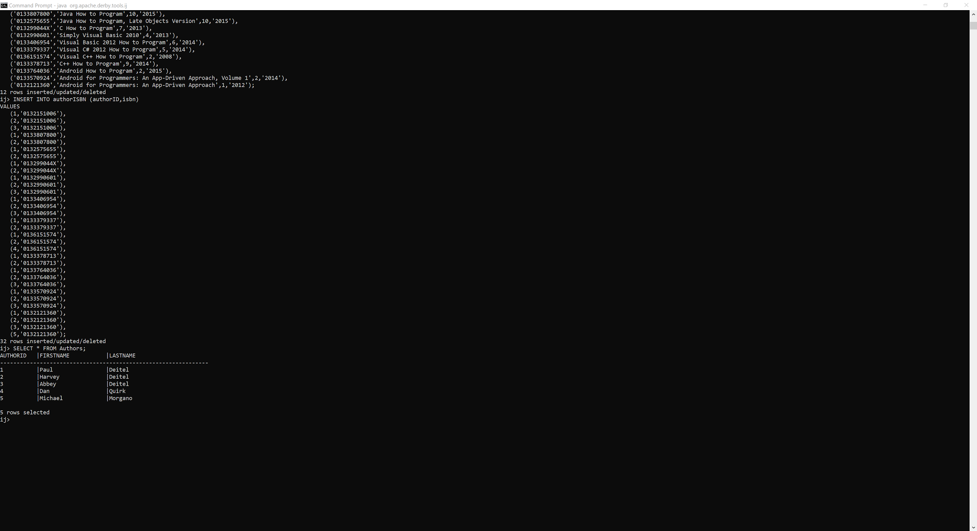

Here is sorting the authors by last name and books.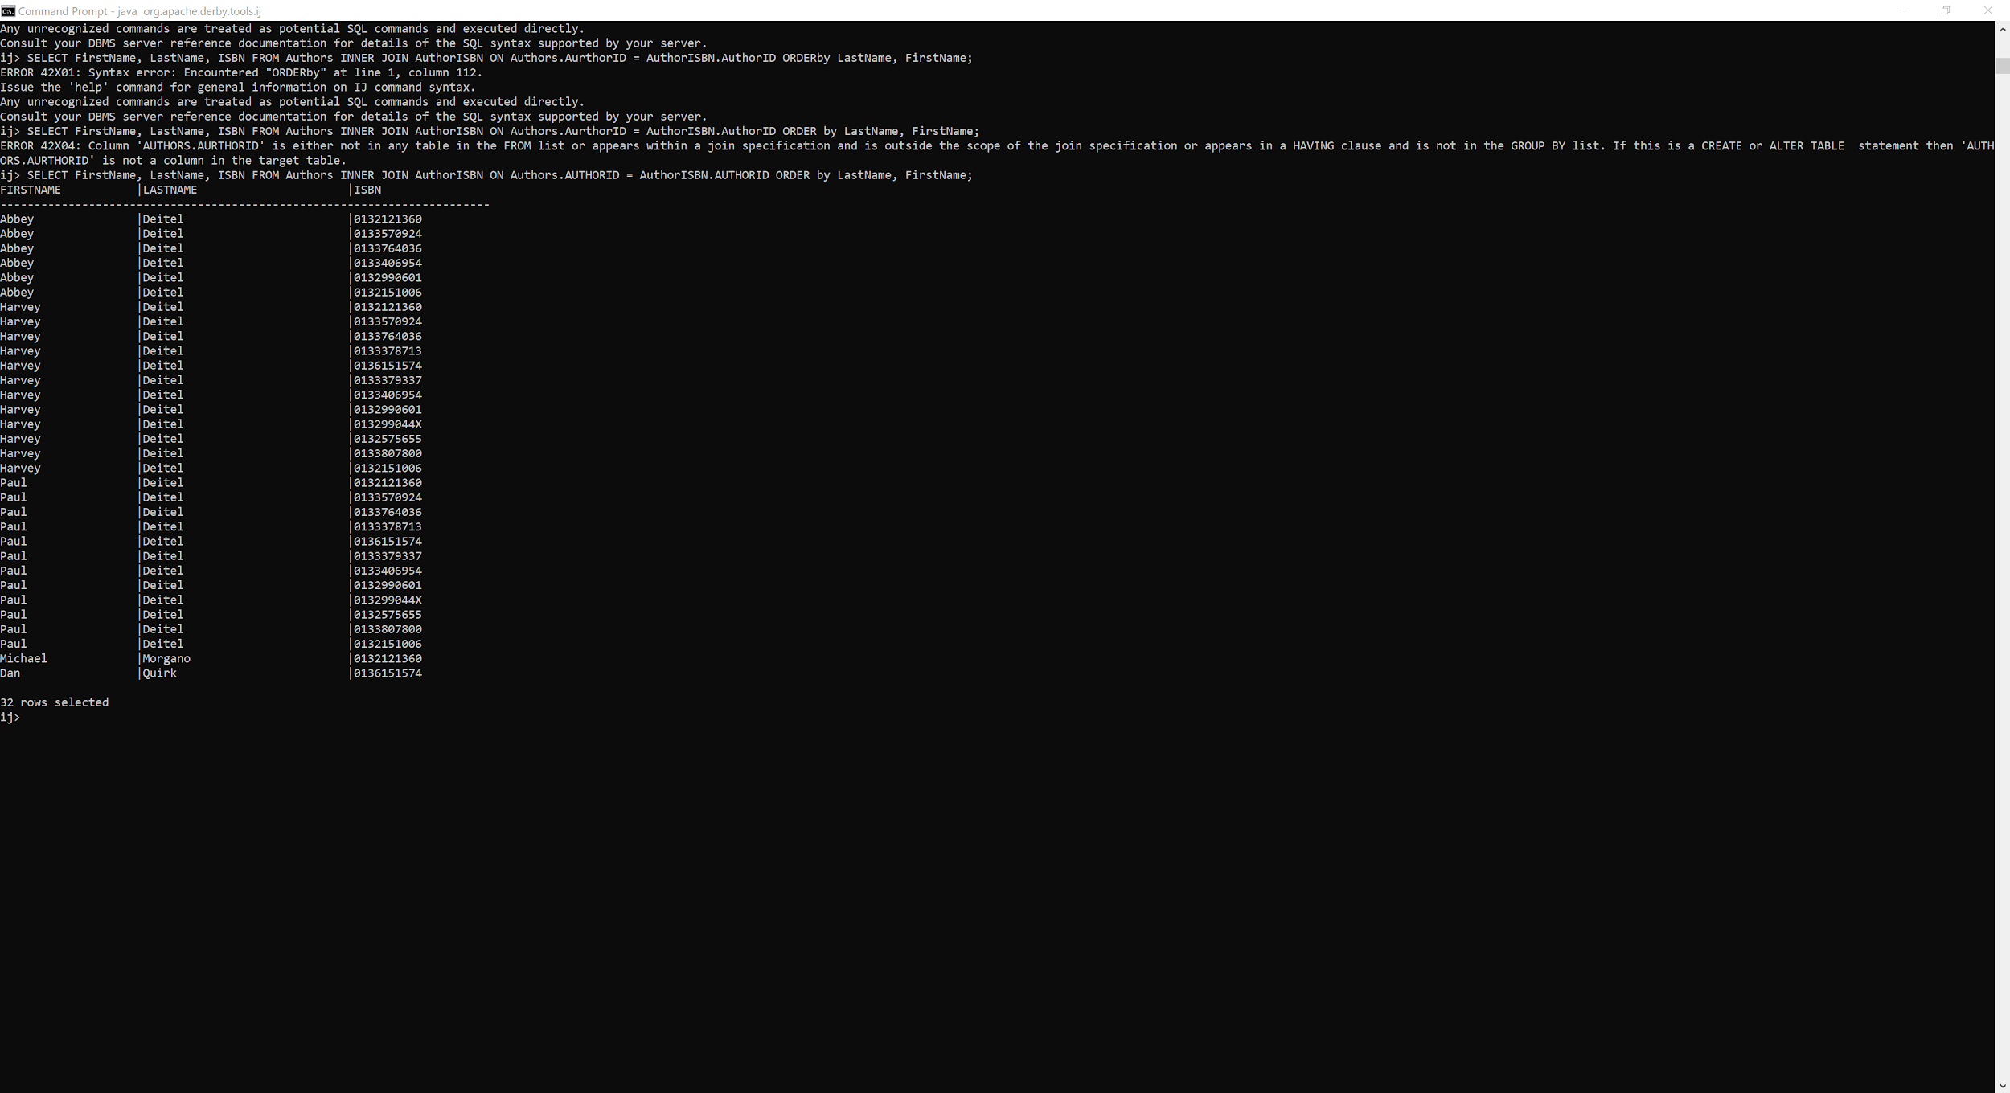

And finally here is a query of me sorting the data by name, ISBN number and book title.

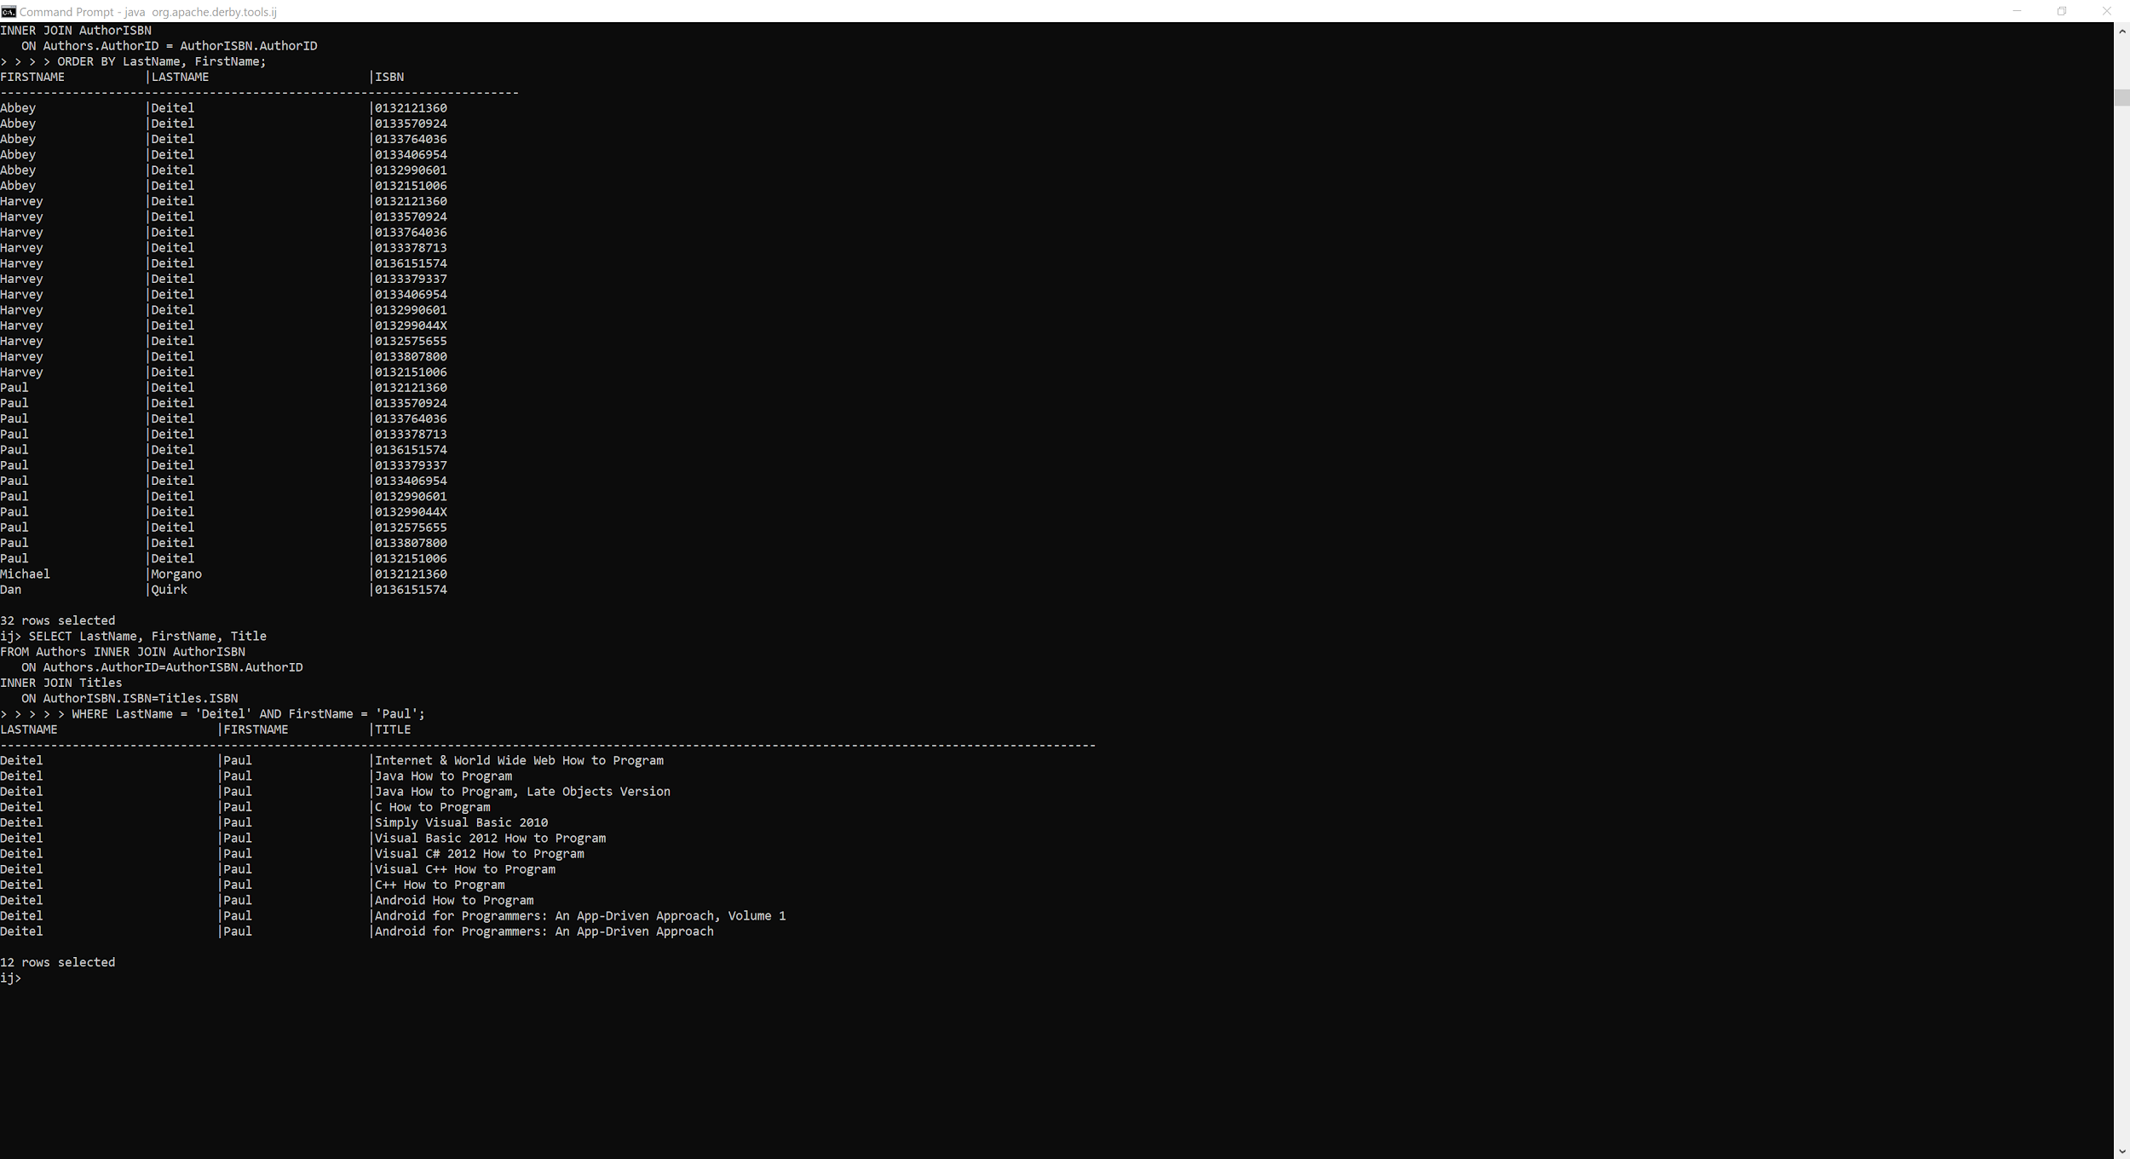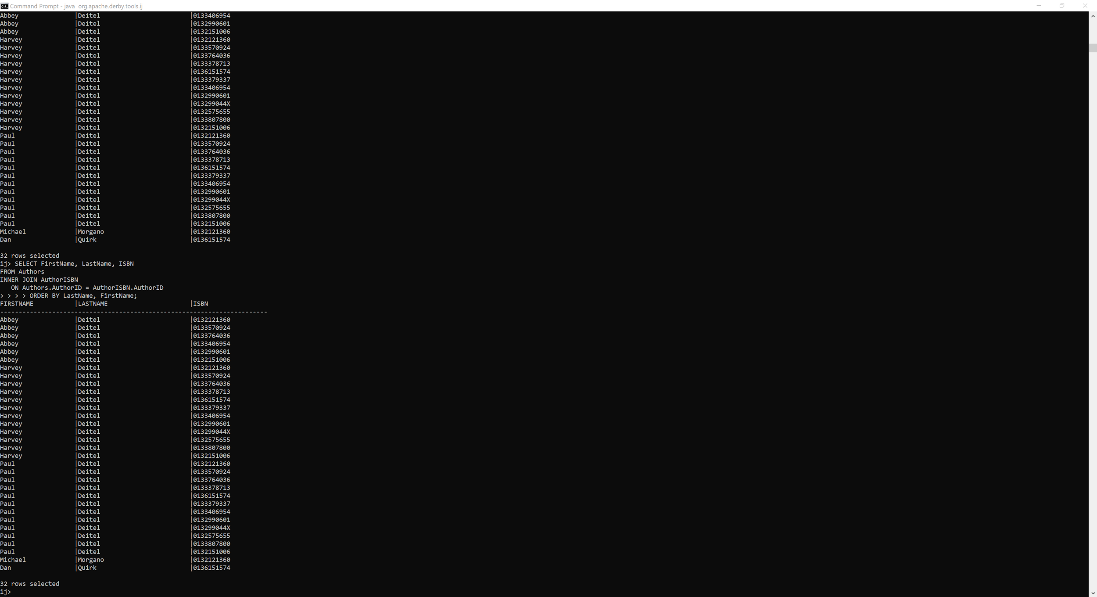

While this isn't exactly the assignment I hoped I demonstrated my understanding of submitting queries. I also included a folder of the code. Thanks!